How to verify an element or its text or button appears appears after some time for example after 10 seconds

This can be achieved with the help of ‘Explicit wait’ with the following method

1. Verification of element text appears after some time

For example, if we click on following blue button, then the text “Selenium Webdriver” text will be appeared after 10 seconds

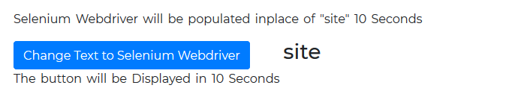

After clicking on above blue button

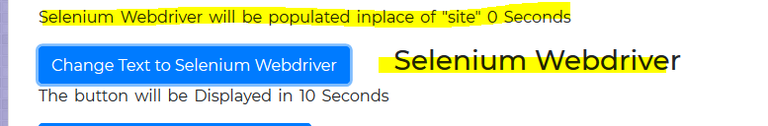

Solution : Use ‘texttobePresentInElement’ method of ‘ExplicitWait’

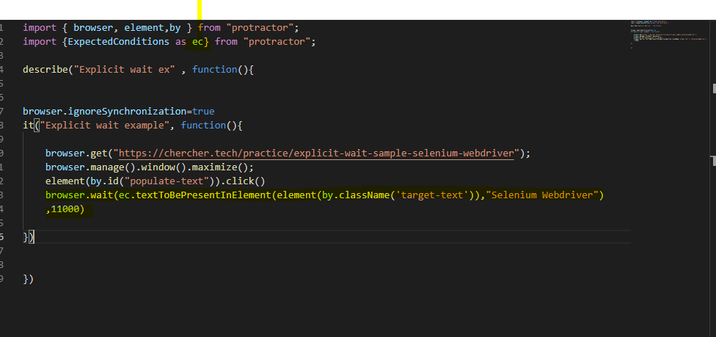

1. Verification of appearance of button appears after some time

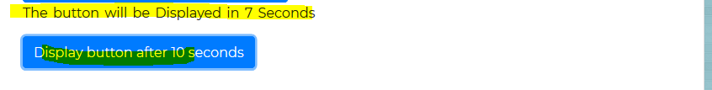

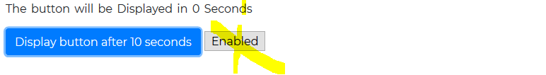

Solution: Use ‘elementTobeClickable’ method

